**Contact Information Application**

**Framework:** Microsoft .NET 4.5

**Technologies Used:**

1. Web API
2. Entity Framework to Retrieve and Update Data.
3. MVC application for UI design and Calling WebAPI.
4. SQL Server for Backend data store.

**How to run the Application:**

**Project Structure:**

1. Unzip the Attached folder and create the folder structure as per screenshot
2. add *ContactInformationMVC* and *ContactInformationWebAPI* project as below.

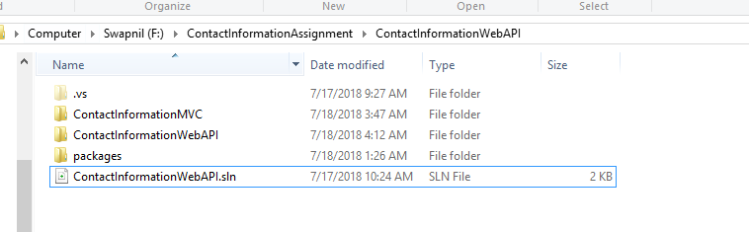

Open the Solution file and add these 2 projects as shown in screenshot and build the application.

Add the packages required if any.

MVC => to Call WebAPI and perform CRUD operations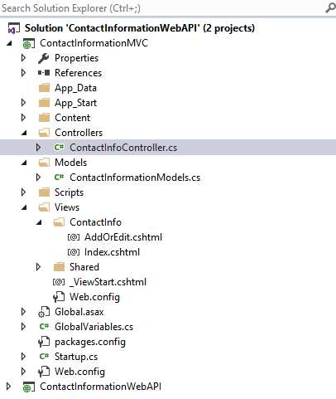

WebAPI => Used Entity Framework and REST to retrieve and Update Data.

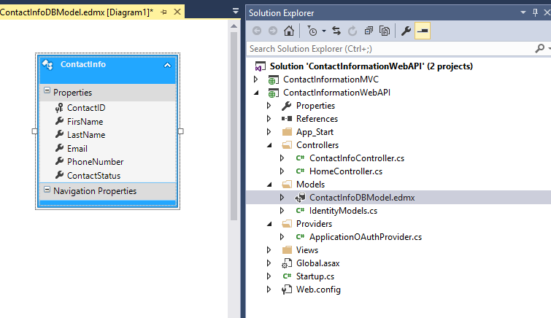

I have created/ Added 2 Project and Both of them are kept as StartUp project.

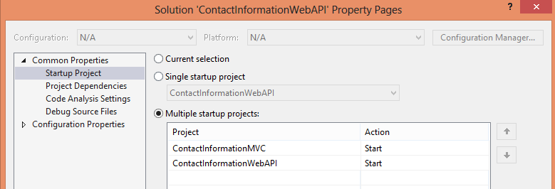

Open the Solution in Visual Studio 2012 or higher version and Run the application.

You will see the Contact Information Page as below

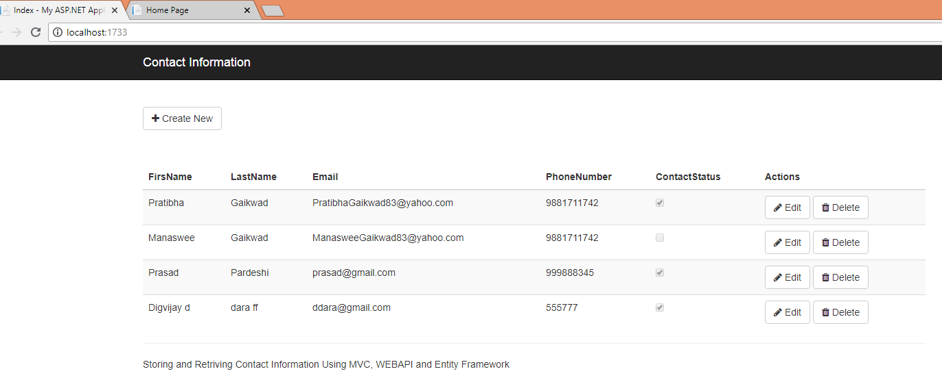

You can click on Create New contact, Edit and Delete Existing Contacts.

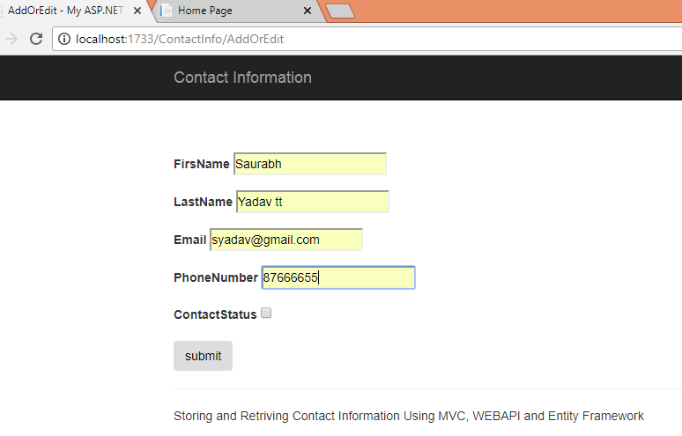

Click on Submit to **Add Contact.**

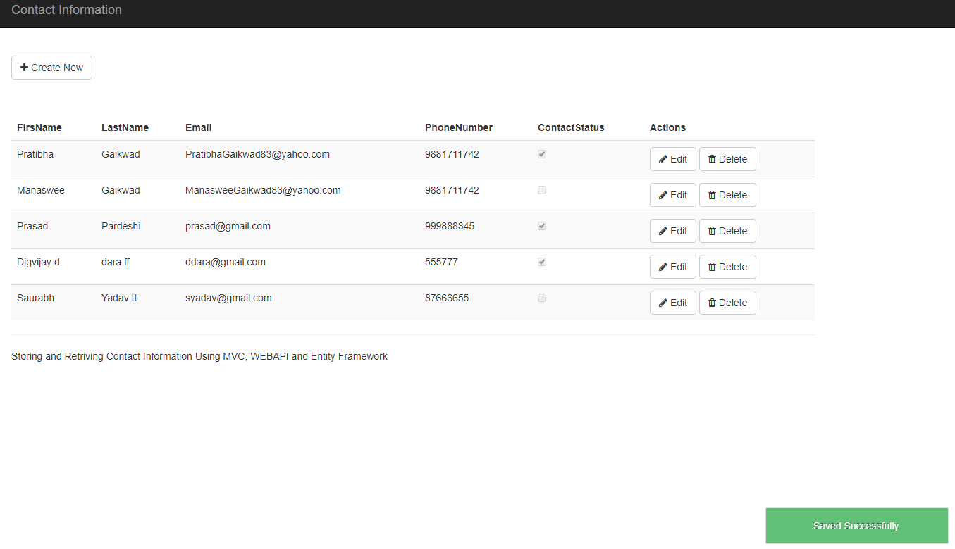

Similarly click on Edit to edit and Delete contact.

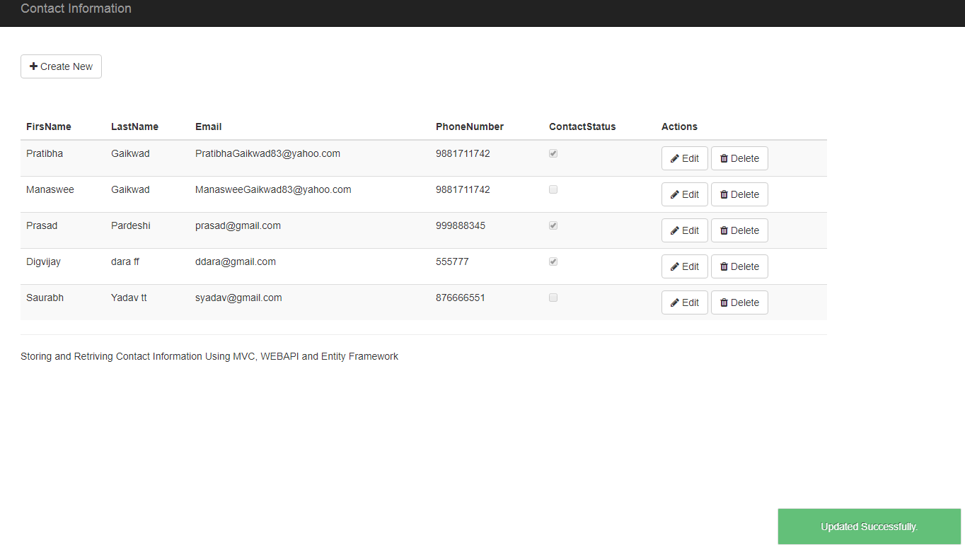

**>> Create Contact_Information Database and Run below script on it.**

USE [Contact_Information]

GO

/****** Object: Table [dbo].[ContactInfo] Script Date: 7/17/2018 10:09:11 AM ******/

SET ANSI_NULLS ON

GO

SET QUOTED_IDENTIFIER ON

GO

CREATE TABLE [dbo].[ContactInfo](

[ContactID] [int] IDENTITY(1,1) NOT NULL,

[FirsName] VARCHAR (15) NOT NULL,

[LastName] VARCHAR (15) NOT NULL,

[Email] VARCHAR (20) NOT NULL,

[PhoneNumber] VARCHAR (10) NOT NULL,

[ContactStatus] bit NOT NULL, -- 1 means Active , 0 - Inactive

CONSTRAINT [PK_ContactInfo] PRIMARY KEY CLUSTERED

(

[ContactID] ASC

)WITH (PAD_INDEX = OFF, STATISTICS_NORECOMPUTE = OFF, IGNORE_DUP_KEY = OFF, ALLOW_ROW_LOCKS = ON, ALLOW_PAGE_LOCKS = ON) ON [PRIMARY]

) ON [PRIMARY]

GO